26th Annual Black Lake Fishing Derby
T-Shirt Logo Contest
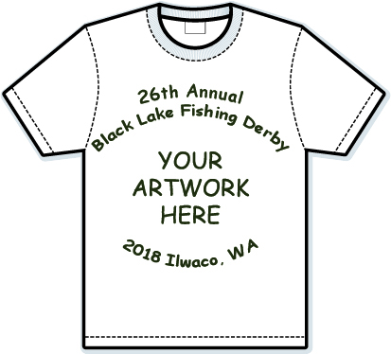 | - Get your logo design on the 2018 Black Lake Fishing Derby T-Shirt and win a prize!  - Open to all students K-12 in the Ocean Beach School District.  - Only one submission per contestant.  - Design must be in black pen or pencil and fit in an 8” x 8” square.  - Include your name, school, grade, parent’s name, parent’s phone and email.  - Submit designs to your school’s office,  in person at Ilwaco City Hall (120 First Av) or mail to: City of Ilwaco, PO Box 548, Ilwaco WA 98624.  - For more information, contact Stephanie Davis at 360.642.3145.  - DEADLINE: MARCH 30, 2018

