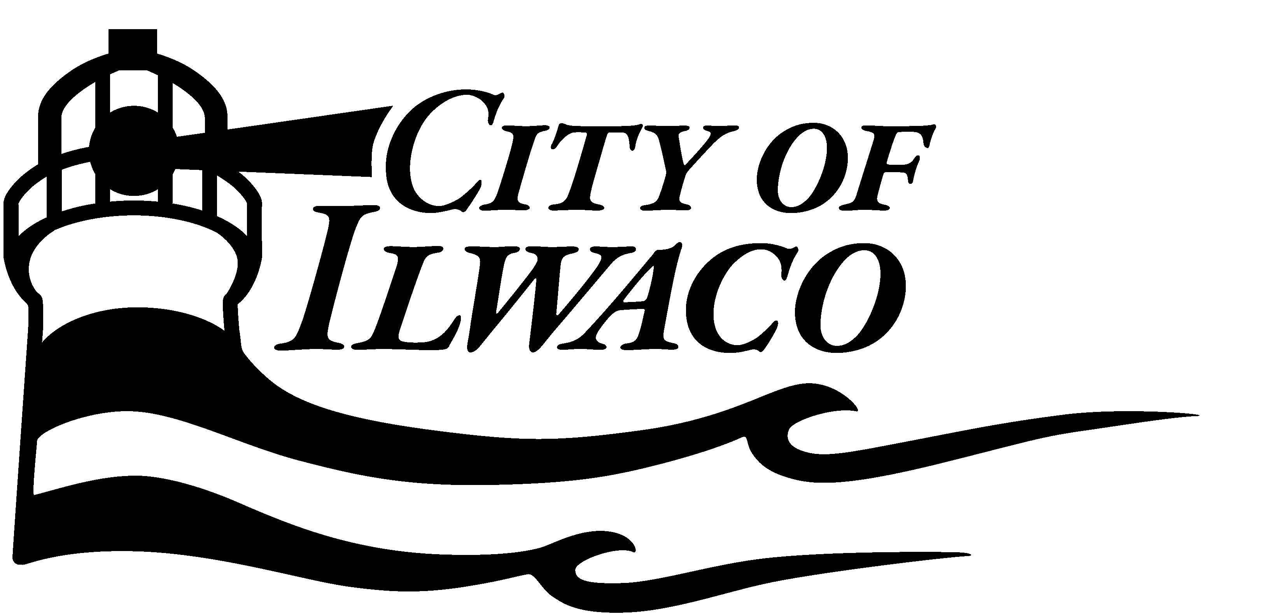
Short Guide to Development in Ilwaco
What is development and how is it regulated by the City?
Development within the City of Ilwaco is regulated under Title 15 (Unified Development Code) and under Title 14 (Development Standards). Under Title 15 the City Planner is charged with administrative responsibility to implement the requirements of Title 15. The two basic types of permits needed to conduct land use activities in Ilwaco are: Development / Zoning Permit under Title 15. Building, street, sewers, utilities, fire code, and drainage, erosion control and storm water management are covered under Title 14. Depending on which chapter of Title 14 is applicable to your project, various approvals may be needed from the Building Inspector, City Engineer and Fire Chief prior to permits being issued.
Receiving a Development / Zoning Permit is generally the first step in the development process, followed by applying for and receiving a Building Permit and/or other applicable approvals under Title 14. For typical projects such as a Single Family Residence both permits can be applied for at the same time and be reviewed concurrently. During the review process other applicable permits may be needed to obtain final approval for your project, which is mentioned below in further detail.
To receive final approval to proceed with your project you will need to obtain final approval from City Hall Staff once all the necessary permits are approved. Currently, the City Clerk maintains a checklist of all applicable permits and approvals identified for a project that will be required. Once the City Clerk has received all approvals needed for your project, he/she will issue your permits, which is the final authorization to proceed.
What’s the difference between a Development / Zoning Permit and a Building Permit?
Development / Zoning Permit: These permits are oriented toward how a project fits into the community: It regulates setbacks, types of uses, height, parking requirements, and design (for some types of projects), etc. The City is divided into zoning districts with each zoning district having its own set of regulations and allowed uses. For example, the regulations that would apply in a single family residential district (R-1) will be different than those for a multi-family zoning district (R-2) or commercial zoning district (C-1). When a Development / Zoning Permit is required for a new development or change of use the City will generally require that an application be accompanied by site plans, building plans, parking plans, etc., depending on the project. During the review process, other applicable permits, reviews, or approvals may be needed from other City Departments. The City Planner recommends that for large complex projects you request a Pre-Application Meeting to help identify what other additional reviews and approvals may be necessary. This will insure a timely review process and avoid lengthy delays. For smaller projects, simply working with the City Planner to identify what additional reviews will be needed prior to the submitting application will ensure your project goes smoothly.
Building Permits: These permits are oriented toward ensuring that structures are constructed to an appropriate standard and are safe for the uses intended to occupy the structure. Applications for most Building Permits must be accompanied by detailed construction drawings. At this time the City of Long Beach handles the building permit review process for the City of Ilwaco. Building and Construction is covered under Title 14.14. Contact the City of Long Beach Building Inspector if you have any questions.
Other Applicable Permits and Reviews: In addition to the above permits the following additional permits approvals/reviews may be necessary in conjunction with a Development / Zoning Permit and Building Permit. This list does not include permits or approvals needed from State and Federal Agencies. The City Planner will work with you to help identify what additional approvals may be needed from other agencies.
1. Right of Way Permit: This permit is required before performing any work within a right-of-way that may be associated with your project. This permit is obtained from the City Engineer. (Title 14.04.210)
2. Sewer and Water System Approval: Prior to installing pipes for sewer or water systems, it may be necessary to obtain approval from the City Engineer. (Title 14.06.170)
3. Side Sewer Permits: This permit is required to connect to the city sewer system. This approval is obtained from the City Engineer. (Title 14.06.130)
4. State Environmental Policy Act (SEPA): This review may be necessary for your project, but is typically for actions that are subject to additional state and federal review, i.e. work within wetlands, aquatic environments, etc. The City Planner can work with you to determine if your project is subject to an environmental review under SEPA. (Title 15.12)
5. Shoreline Permits: These permits are for land use actions that are located within 200 feet of the Ordinary High Water Mark (OHWM) from water bodies identified in the City of Ilwaco Shoreline Master Program and for projects located within the 100 year floodplain. All uses, activities and/or developments within shoreline jurisdiction are subject to a shorelines review. Shoreline approvals are as follows: Shoreline Exemption, Substantial Development Permit, Conditional Use Permit, and Shoreline Variance Permit. (Title 15.14 – City of Ilwaco Shoreline Master Program)
6. Floodplain Review (Development Permit): This permit is required for any development proposed within the 100 year floodplain. This permit is specifically tied to certain development standards and building standards that are required to meet FEMA regulations under the Flood Insurance Program. It also is a review to ensure your project does not impact the storage capacity or flow of flood waters within the flood plain for activities such as the placement of fill. This permit is issued simultaneously with your Planning / Zoning Permit and does not require a separate application. (Title 15.16)
7. Critical Areas Review: This review is required for any development undertaken within an area identified as a critical area. These areas are identified as being Wetlands, Fisheries Habitat, Shellfish, Kelp, Eelgrass, Herring and Smelt Spawning Areas, Wildlife Habitat, Frequently Flooded Areas, and Geologically Hazardous Areas. When an applicant is seeking a Development Permit or otherwise engaging in an activity covered under the City of Ilwaco’s Critical Areas Ordinance No. 614 a Critical Areas Checklist will be required prior start of the proposed land use action. (Title 15.18 – City of Ilwaco Critical Areas Ordinance)
8. Fire Chief Approval: Approval for commercial development regulated under Title 15 must receive final approval from the City of Ilwaco Fire Chief prior to final approval of all permits for the proposed development project. Review by the Fire Chief is typically required for commercial buildings constructed or developed within the city, commercial buildings that are substantially altered, buildings that are served by water mains, fire hydrants, plat development and residential complex development. (Title 14.16)
9. Sign Permits: This permit is required for any new signs erected within the city and for alterations of existing signs. Existing signs within the City that are considered grandfathered, must conform to current regulations if the sign is altered and/or replaced. Some signs don’t require a Sign Permit prior to being erected, installed, affixed, altered or relocated. Check with the City Planner for further information. (Title 15.45.070)
10. Landscaping Plan: A landscaping plan is required for some uses within the city. Typically these uses are commercial related activities. Landscaping requirements for each zoning district can be found in Title 15.47. The City Planner is responsible for review and approval for landscaping plans.
11. Stormwater System Design: This approval is typically needed for storm sewers constructed within the street for large development such as sub-divisions where a developer is installing large systems. This review is completed by the City Engineer (Title 14.08.050).
12 Stormwater Management Review: This approval is applicable to all developments to control runoff from going onto adjacent properties or into water bodies of the state. Typically the Planner will condition your Development / Zoning Permit with stormwater control measures necessary to meet the applicable regulations. The City Engineer reviews and approves all stormwater management plans and provides conditions to the City Planner to place on your permit and/or may issue their own approval. (Title 14.08)
13. Erosion Control and Sedimentation: This approval is completed by the City Engineer for all development activities in the City of Ilwaco that have a potential to discharge runoff from the site. (Title 14.08)

